**Subject-based project**

**Theory of automata and formal languages**

**Project Title:**

Traffic Light Time Management System using DFA

**Abstract:**

Traffic management is a crucial component of modern smart cities. This project presents a simple model of traffic light control using Deterministic Finite Automata (DFA). The system cyclically transitions between Red, Green, and Yellow states based on timer expirations. The DFA model ensures structured, predictable traffic flow with minimal human intervention.

**Purpose of the Project:**

* To model a traffic light control system using formal methods (DFA).
* To demonstrate the application of finite automata in real-world automation.
* To ensure safe, efficient, and automated management of traffic at intersections.

**Applications:**

* Urban traffic signal control at road intersections.
* Pedestrian crossing systems.
* Traffic light simulation for educational tools.
* Adaptive traffic control systems (advanced version)

**Description:**

The system has three states:

* **Red**: Vehicles must stop.
* **Green**: Vehicles are allowed to move.
* **Yellow**: Vehicles must prepare to stop.

Each state transition occurs after a fixed timer expires.  
The system cycles indefinitely between the states in the following sequence:

**Red → Green → Yellow → Red → Green → Yellow → ...**

There is no external input from drivers; the system works on timer signals internally.

Thus, the DFA is simple, cyclic, and deterministic.

**Regular Expression (RE):**

Since the behavior is cyclic and predictable, the RE can be modeled as:

(Red TimerExpired)(Green TimerExpired)(Yellow TimerExpired)*

**Transition Graph(TG):**

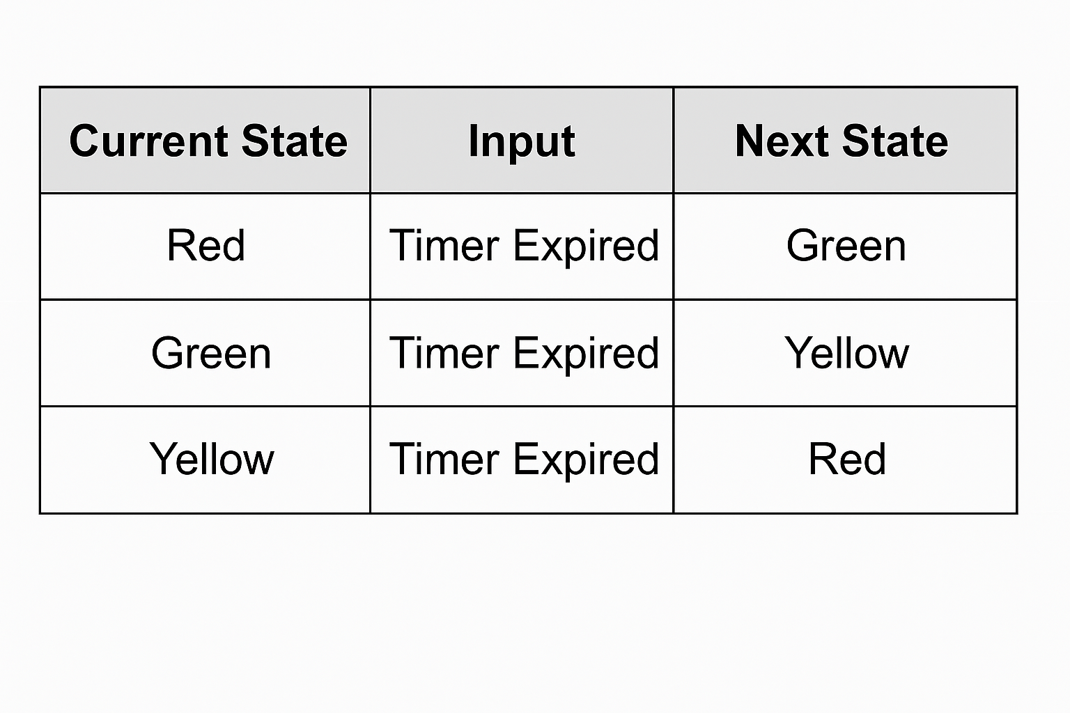

**DFA Diagram (text version):**

* **States**: {Red, Green, Yellow}
* **Alphabet**: {Timer Expired}
* **Start State**: Red
* **Transitions**:
  + δ(Red, TimerExpired) = Green
  + δ(Green, TimerExpired) = Yellow
  + δ(Yellow, TimerExpired) = Red
* **Accepting States**: {Red, Green, Yellow} (optional)

**Code:**



